Name _________________________________________________________________________________

Module 1 Packet

DECIMAL OPERATIONS

Standard 6.NS.B Compute fluently with multi-digit numbers.

In Module 1, you will learn how to…
- ___ 1-1 Find sums and differences of decimals (6.NS.B.3)
- ___ 1-2 Find products of decimals (6.NS.B.3)
- ___ 1-3 Estimate digits in a quotient (6.NS.B.2)
- ___ 1-4 Divide multi-digit numbers using the standard algorithm (6.NS.B.2)
- ___ 1-5 Divide multi-digit decimals using the standard algorithm (6.NS.B.3)
- ___ 1-6 Apply decimal operations to problem solving (6.NS.B.3 and MP.1)

AUGUST 16 - AUGUST 29

Your Grade for 6.NS.B
The skills and concepts that you learn in this packet will appear as your grade for 6.NS.B Number Fluency.
A = 4 EXCEEDS | You exceed the learning targets in understanding or application.
B = 3 MEETS | You have met all the learning targets for this standard.
C = 2 DEVELOPING | You are approaching the standards or have only partial understanding.
D = 1 WELL BELOW | You have not yet met many of the standards.

Name _________________________________________________________________________________

6.NS.B.3 Lesson 1-1

Sums and Differences of Decimals

Learning Target: I can fluently add and subtract multi-digit decimals using the standard algorithm. (6.NS.B.3)

Do Now

Opening- Explore Activity
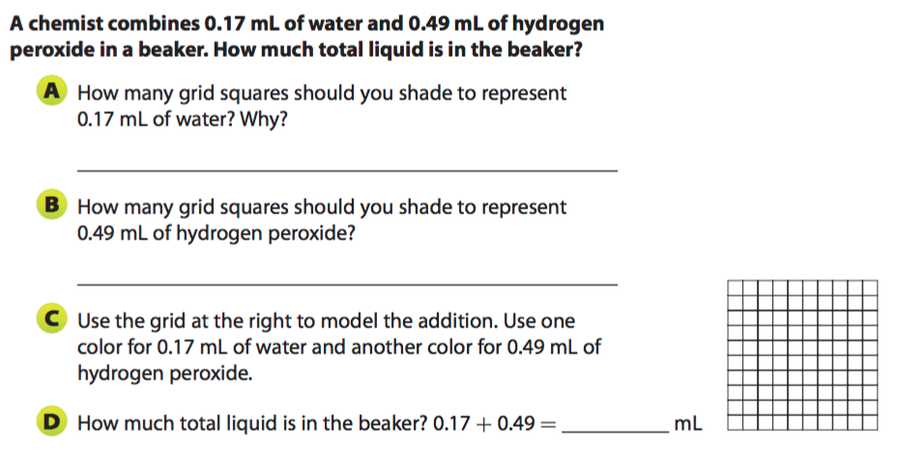

Example 1
Adding decimals is similar to adding whole numbers. First align the numbers by place value. Add zeros as placeholders when necessary. Start adding at the right and regroup when necessary. Bring down the decimal point into your sum.

Susan rode her bicycle 3.12 miles on Monday and 4.7 miles on Tuesday. How many miles did she ride in all?
Solve: | Estimate:

Why can you rewrite 4.7 as 4.70?

Why is it important to align the decimal points when adding?

Exercises

Calculate each sum. Then estimate to check if your answer is reasonable.

- 0.42 + 0.27 = _______ 2) 0.61 + 0.329 = _______

- Perry connects a blue garden hose and a green garden hose to make one long hose. The blue hose is 16.5 feet. The green hose is 14.75 feet. How long is the combined hose?

Example 2- Subtracting Decimals

The procedure for subtracting decimals is similar to the procedure for adding decimals. First align the numbers by place value. Add zeros as placeholders when necessary. Start subtracting at the right and regroup when necessary. Bring down the decimal point into your difference.

Matthew throws a discus 58.7 meters. Zachary throws the discus 56.12 meters. How much farther did Matthew throw the discus?
Solve: | Estimate:

Exercises

Calculate each difference. Then estimate to check if your answer is reasonable.

- 18.419 - 6.47 = _______ 2) 5.006 - 3.2 = _______

- Ms. Tulips bought $56.12 worth of groceries. However, she had coupons worth $9.85. How much did Ms. Tulips spend for groceries?

Problem Set

Calculate each sum or difference. Then estimate to check if your answer is reasonable.

1) 5.4 + 8.7 = 2) 74.906 + 0.03 + 42 = 3) 462 - 31.2 =

4) 28.341 + 37.5 = 5) 25.36 - 2.004 = 6) 150.25 - 78 =

10) A band can play as much as 8 minutes of music in a competition. If a band plays a 2.33 minute song and a 4.25 minute song, how many minutes does it have left?

11) You receive $50 for your birthday. You buy a book for $14.95 and a baseball cap for $24.95. How much money do you have left?

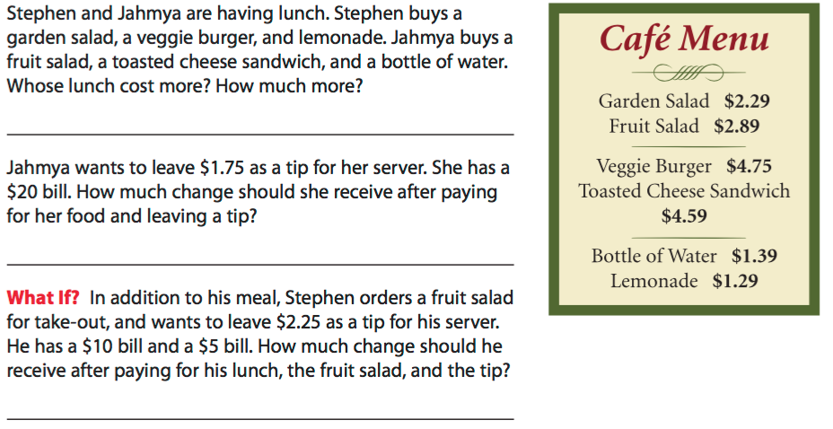
Use the cafe menu to answer 12-14. Show your work in the space below.
13)
14)
12)
Name _________________________________________________________________________________

6.NS.B.3 Lesson 1-2

Products of Decimals

Learning Target: I can fluently multiply multi-digit decimals using the standard algorithm. (6.NS.B.3)

Do Now

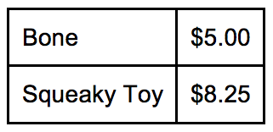
Opening- Partner Work

Mrs. Jones is shopping for her quadruplets. Her quadruplet puppies are very jealous of each other and as a result, she must buy them all the same things. She decides to buy each of her quadruplets the two different items listed below. What is the total price of all the gifts?

Directions: Use the space below to show how your group calculated the total cost of the items. Show all your work. Draw a box around your final answer. | Discussion Question:  - What did you notice between how your group solved the problem and how other groups did?

Example 1- Multiplying Decimals
Why we estimate:

1.

2.
- Estimate the area of the rectangle below.

2.12 ft.
405 ft.

How to multiply decimals:

-

-

-

2. Calculate the area of the rectangle using the
standard algorithm.

*Compare your estimate to your calculated product. ……..Is our answer reasonable? Explain:

Example 2
Think about it!
In the space below write twelve dollars and fifty cents. Label each place value.

$ ___ ___ . ___ ___

IMPORTANT:
Money only has ____ decimal places.
This means you must _________ to the nearest penny.
Xavier earns $11.75 per hour working at the commissary. Last week, Xavier worked 13.5 hours. How much money did he earn?
Estimate:

Standard Algorithm:

Exercises
Directions: Calculate the product of each problem below. First, estimate your answer, then show your work.
Problem | Estimate your Answer | How many decimal digits should your answer have? | Use the Standard Algorithm
- 25.4 x 9
- 8.1 x 12.34
- $19.30 x 1.85
- $2.79 x $0.67

Problem Set
Show all your work. Draw a box around your final answer.

- Calculate the product: 2. Calculate the product:
1.9 x 3.8 15.6 x 12.3

3. Calculate the product: 4. Calculate the product:
18.9 x 3.24 24.56 x 4.82

5. Kevin spent $11.25 on lunch every week during the school year. If there are 35.5 weeks during the school year, how much does Kevin spend on lunch over the entire school year?
Remember to round to the nearest penny. ________________
6. The principal of East High School wants to buy a new cover for the rectangular sand pit used for the long-jump competition. He measured the sand pit and found that the length is 29.2 feet and the width is 9.8 feet. What will the area of the new cover be?
___________________

Name _________________________________________________________________________________

6.NS.B.2 Lesson 1-3

Estimating Digits in a Quotient

Learning Target: I can fluently divide multi-digit numbers using the standard algorithm. (6.NS.B.2)

Do Now

Opening- Discussion
Divide 150 by 3

Key Vocabulary
dividend $÷$ divisor = quotient  dividend  divisor  quotient  dividend  divisor  = quotient | 472 $÷$ 8 = 59  472  8  59  $\frac{472}{8}$= 59

Example 1- Rounding to a One-Digit Arithmetic Fact

Exercises
1)
4,752 $÷$12
- Round to a one-digit arithmetic fact. Estimate the quotient. | - Use a calculator to find the quotient. Compare the quotient to the estimate.

2)
11,647 $÷$19
- Round to a one-digit arithmetic fact. Estimate the quotient. | - Use a calculator to find the quotient. Compare the quotient to the estimate.

Example 2- Estimates Further Away
59,262 $÷$14

Exercises
1)
49,170 $÷$15
- Round to a one-digit arithmetic fact. Estimate the quotient. | - Use a calculator to find the quotient. Compare the quotient to the estimate.

Example 3- Extend Estimation and Place Value to the Division Algorithm
918$÷$27
- Round to estimate the quotient. | b) Division Algorithm.

Problem Set

1)
715 $÷$11
- Round to estimate the quotient. | - Use a calculator to find the quotient. Compare the quotient to the estimate.

2)
9,646 $÷$13
- Round to estimate the quotient. | - Use a calculator to find the quotient. Compare the quotient to the estimate.
3)

48,825 $÷$15
- Round to estimate te quotient. | - Use a calculator to find the quotient. Compare the quotient to the estimate.

4)
199,988 $÷$17
- Round to estimate the quotient. | - Use a calculator to find the quotient. Compare the quotient to the estimate.

6.NS.B.2 Lesson 1-4

Dividing Multi-Digit Numbers Using the Algorithm

Learning Target: I can fluently divide multi-digit numbers using the standard algorithm. (6.NS.2)

Do Now

Example 1- Dividing Whole Numbers Using the Standard Algorithm
Divide 70,072 $÷$ 19

- Estimate:

b) Create a table to show the multiples of 19.

Multiples of 19

c) Use the algorithm to divide 70,072$÷$19. Check your work.

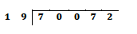

Example 2- Dividing Whole Numbers Using the Standard Algorithm
Divide 14,175$÷$315

- Estimate. b) Use the algorithm to divide 14,175$÷$315. Check your work.

Example 3- Dividing with a Remainder
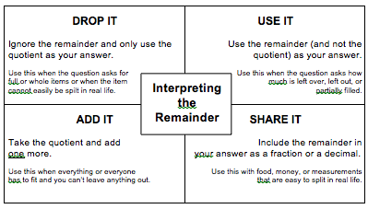

Callie has 1,850 books. She must pack them into boxes to ship to a bookstore. Each box holds 12 books. How many boxes will she need to pack all of the books.

- Divide using the standard algorithm:

- What does the remainder mean in this situation? What should you do to the remainder?

- How many boxes does Callie need to pack the books? Explain.

Exercises
- 484,692 $÷$78
  - Estimate: b) Divide using the algorithm:

2) 2,295,517 $÷$ 37
- Estimate: b) Divide using the algorithm:

3) 952,448 $÷$ 112
- Estimate: b) Divide using the algorithm:

4) A local zoo had a total of 98,464 visitors last year. The zoo was open every day except three holidays? On average, how many visitors did the zoo have each day?

5) A museum gift shop manager wants to put 1,578 polished rocks into small bags to sell as souvenirs. If the shop manager wants to put 15 rocks in each bag, how many complete bags can be filled? How many rocks will be left over?

Problem Set
1) 34,874 $÷$ 53
- Estimate: b) Divide using the algorithm:

2) 70,434 $÷$ 78
- Estimate: b) Divide using the algorithm:

3) 182,727 $÷$ 257
- Estimate: b) Divide using the algorithm:

6) Camilla makes and sells jewelry. She has 8,160 silver beads and 2,880 black beads to make
necklaces. Each necklace will contain 85 silver beads and 30 black beads. How many necklaces can
she make?

7) There are 1,012 souvenir paperweights that need to be packed in boxes. Each box will hold 12
paperweights. How many boxes will be needed?

Name _________________________________________________________________________________

6.NS.B Lesson 1-5

Dividing Decimals

Learning Target: I can fluently divide multi-digit decimals using the standard algorithm. (6.NS.B.3)

Do Now

Opening- Explore Activity
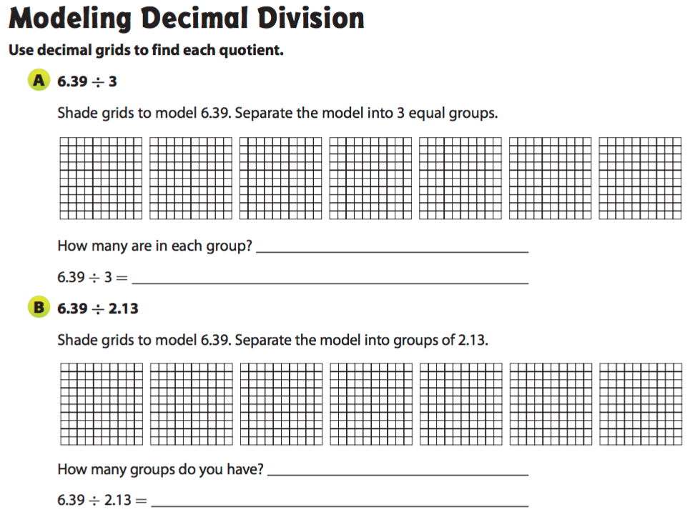

Example 1- Dividing Decimals by Whole Numbers

Dividing decimals is similar to dividing whole numbers. When you divide a decimal by a whole number, the placement of the decimal point in the quotient is determined by the placement of the decimal in the dividend.

- A high school track is 9.76 meters wide. It is divided into 8 lanes of equal width for track and field events. How wide is each lane?

- Divide using long division as with whole numbers.
- Place a decimal point in the quotient directly above the decimal point in the dividend.

B) Aerobics classes cost $153.86 for 14 sessions. What is the fee for one session?

- Divide using long division as with whole numbers.
- Place a decimal point in the quotient directly above the decimal point in the dividend.

Exercises
- 9.75 $÷$ 5 2) 6.44 $÷$ 7

Example 2- Dividing a Decimal by a Decimal
Multiplying Decimals by Powers of 10

* Look for patterns-- Patterns can help you place the decimal point in the product. *
3.85 X 1 = ________  3.85 X 10 = ________  3.85 X 100 = ________ | 0.264 X 1 = ________  0.264 X 10 = ________  0.264 X 100 = ________  0.264 X 1000 = ________
As you multiply by increasing powers of 10, how does the position of the decimal point change in the product?

When dividing a decimal by a decimal, first change the divisor to a whole number by multiplying the divisor by a power of 10. Then, multiply the dividend by the same power of ten.

- Ella uses 0.5 pounds of raspberries in each raspberry cake that she makes. How many cakes can Ella make with 3.25 pounds of raspberries?
Step 1  The divisor has _____ decimal place, so multiply both the dividend and the divisor by _____ so that the divisor is a whole number.  3.25 $÷$ 0.5  $\frac{3.25}{0.5}$X = | Step 2  Divide:

B) Anthony spent $11.52 for some pens that were on sale for $0.72 each. How many pens did
Anthony buy?
Step 1  The divisor has _____ decimal places, so multiply both the dividend and the divisor by _____ so that the divisor is a whole number. | Step 2  Divde:

Exercises

- 4.75 $÷$ 0.5 2) 15.12 $÷$ 0.84

Problem Set
Divide.

- 29.5 $÷$ 4 2) 10.261 $÷$ 3.1

3) 90 $÷$ 0.36 4) 23.85 $÷$ 9

5) 18.88 $÷$ 1.6 6) 0.234 $÷$ 0.78

7) Corinne has 9.6 pounds of trail mix to divide into 12 bags. How many pounds of trail mix will go in
each bag?

8) Michael paid $11.48 for sliced cheese at the deli counter. The cheese cost $3.28 per pound. How
much cheese did Michael buy?

9) A four-person relay team completed a race in 72.4 seconds. On average, what was each
runner’s time?

10) Elizabeth has a piece of ribbon that is 4.5 meters long. She wants to cut it into pieces that are
0.25 meter long. How many pieces of ribbon will she have?

11) A movie rental website charges $5.00 per month for membership and $1.25 per movie.

- How many movies did Andrew rent this month if this month’s bill was $16.25?

b) Marissa has $18.50 this month to spend on movie rentals.

How many movies can Marissa view this month?

Marissa thinks she can afford 11 movies in one month. What mistake could she be making?

Name _________________________________________________________________________________

6.NS.B Lesson 1-6

Apply Decimal Operations to Problem Solving

Learning Target: I can fluently add, subtract, multiply, and divide multi-digit decimals using the standard algorithm for each operation. (6.NS.B.3)

Do Now

Opening- Group Work
Problem Solving - Keywords Activity Sort
Addition | Subtraction | Multiplication | Division

Example 1
Word problems contain information that helps you choose which operation to use. Look for clues to help you decide whether to multiply or divide. Read the problem carefully. What is given? What are you asked to find?
Problem 1: Four friends equally shared the cost of supplies for a picnic. The supplies cost $12.40. How much did each pay?
Given Information | Keyword(s) | Operation

Example 2
Not all problems can be solved using just one operation. Sometimes, word problems give you enough information that you are required to do more than one step to solve. These types of problems are called multi step word problems.
Problem 2: Cindy works part-time and earns $5.75 an hour. One year she worked 50 weeks and averaged 12.4 hours of work per week. About how much money did she earn that year?
Given Information | Keyword(s) | Operation
First:

Second:

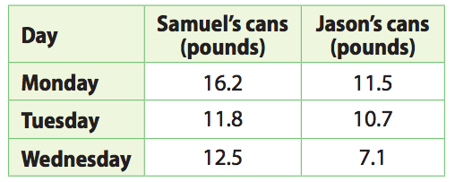
Exercises
- Samuel and Jason sell cans to a recycling center that pays $0.40 per pound of cans. The table shows the number of pounds of cans that they sold for several days.
- Samuel wants to use his earnings from Monday and Tuesday to buy some batteries. What are his total earnings?

Given Information | Keyword(s) | Operation

- The batteries Samuel wants to buy cost $5.60 each. How many batteries can Samuel buy?
Given Information | Keyword(s) | Operation

- Jason wants to use his earnings from Monday and Tuesday for online movie rentals. The movies cost $2.96 each to rent. How many movies can Jason rent? Show your work.

Given Information | Keyword(s) | Operation
c. Samuel and Jason spend $5.67 of their combined earnings from Wednesday to buy a gift. What did they earn Wednesday? _______________ Is there enough left over from Wednesday’s earnings to buy a card that costs $3.25? Explain.____________________________________________________________________________________________________________________________________________________________
Given Information | Keyword(s) | Operation

Problem Set
1.Plastic forks come in packs of 6. You need 40 for a party. How many packs of forks should you buy? |  | 2.Twenty people are going by van to a movie. Each van seats 8 people. How many vans are needed to take everyone?
3.Ricki has 76.8 feet of cable. She cuts off 6 pieces that measure 4.5 feet. How much cable is left over? |  | 4.Jan has $37.50. She then spent $12.95 on a T-shirt. Tickets to a concert cost $5.25 each. How many tickets can Jan buy?
5.Harold bought 3 pounds of red apples and 4.2 pounds of green apples from a grocery store where both kinds of apples are $1.75 a pound. How much did Harold spend on apples? |  | 6.Chanasia has 8.75 gallons of paint. She wants to use half of the paint to paint her living room. How many gallons of paint will Chanasia use?
7. Naomi earned $54 mowing lawns in two days. She worked 2.5 hours yesterday and 4.25 hours today. If Naomi was paid the same amount for every hour she works, how much did she earn per hour? |  | 8. Nadia charges $7.50 an hour for babysitting. She babysits 18.5 hours the first week of the month and 20 hours the second week of the month. To calculate how much she has earned, Nadia writes 7.5 × 18.5 + 20 = $158.75. Explain her error. Show the correct solution.

Name ________________________________________________________________________________

Module 1 Review

Module 1 Study Guide Review
Lesson | Practice
1-1 Find sums and differences of decimals | - 2.19 + 34.925 | - 9.7 - 7.16
 | C. On Saturday Keisha ran 3.218 kilometers. On sunday she ran 2.41 kilometers. How much farther did she run on Saturday than on Sunday?
1-2 Find products of decimals | - 35.15 x 3.7 | B. Martha walked at 3.9 miles per hour for 0.71 hours. How far did she walk?
1-3 Estimate digits in a quotient | - Is 40 a reasonable estimate of a quotient for 78,114
1-4 Divide multi-digit numbers using the algorithm | - There are 3,863 shirts to pack into boxes that hold 120 shirts. How many boxes will be needed if all the shirts have to be packed into a box. | B. Lisa has 21,048 buttons that need to be sorted equally into 12 jars. How many buttons will be in each jar?
1- 5 Divide multi-digit decimals using the algorithm | - 33.475 $÷$ 0.65 | B. Corin bought 8.4 pounds of almonds she divided them in 30 snack size bags. How many pounds are in each bag?
1-6 Apply all decimal operations to problem solving | - Keri walk her dog every morning. The length of the walk is 0.55 kilometer on each weekday. On each weekend day, the walk is 1.4 times as long as her walk on a weekday. How many kilometers does Keri walk in one week? | B. To prepare for a wedding, Aiden bought 60 candles. He paid $0.37 for each candle. His sister bought 170 candles at a sale where she paid $0.05 less for each candle than Aiden did.  - How much did Aiden spend on candles?  - How much did Aiden’s sister spend on candles?  - Who spent more on candles? How much more?

