Name _______________________

Ancient China Unit 2
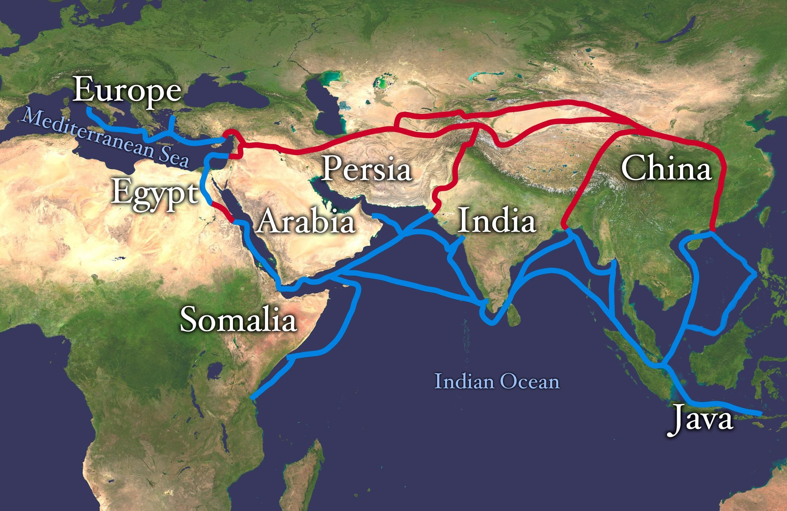
Essential Question:
Should We Call It the “Silk Road”??

Table of Contents

Lesson 1: What was the "Silk Road"?
Source A: Nat Geo 3.1 Silk Road
Source B: Excerpt from Travels of Marco Polo
Source C: BrainPOP Video: Silk Road
Formative Assessment: Quiz Questions

Lesson 2: Why was silk so important?
Source A2: Excerpt from Suleiman
Source B2: Excerpt from “Silk Road: Connecting People and Cultures”
Formative Assessment: Skits

Lesson 3: What, besides silk and other goods, was shared on the Silk Road?
Source A3: Excerpt from Letter to the West
Source B3: Nat Geo Article: The Third of the Century Crisis
Source C3: BrainPOP Video: Fall of the Roman Empire
Formative Assessment: Skits

Lesson 4: What else could this trade network be called?
Source A4: Excerpt from “Following the Mythical Road”
Source B4: Excerpt from “The Silk Road in World History: A Review Essay”
Summative Assessment: Voicethreads

Lesson 5: Create an Outline- Should We Call It the “Silk Road”??

Lesson 6: Write First Draft and Complete 2 Peer Reviews

Lesson 7:: Summative Assessment: Final Draft- Should We Call It the “Silk Road”??

Ancient China Unit 2
Lesson 1: What was the "Silk Road"?
Learning Target:
- I can illustrate exchanged commodities (goods) and their movements along the trade routes.
Do Now: How do people benefit from trading across the world?
_____________________________________________________________________________________________________________________________________________________________________________________________________________________________________________________________________________________________________________________________________________________________________________
Notes: Go through each source and record notes in the designated spot. Focus your learning towards the learning target.

Lesson 1 Source A: Nat Geo 3.1 Silk Road
Notes
2 Questions:

Lesson 1 Source A: Nat Geo 3.1 Silk Road (1 of 2)
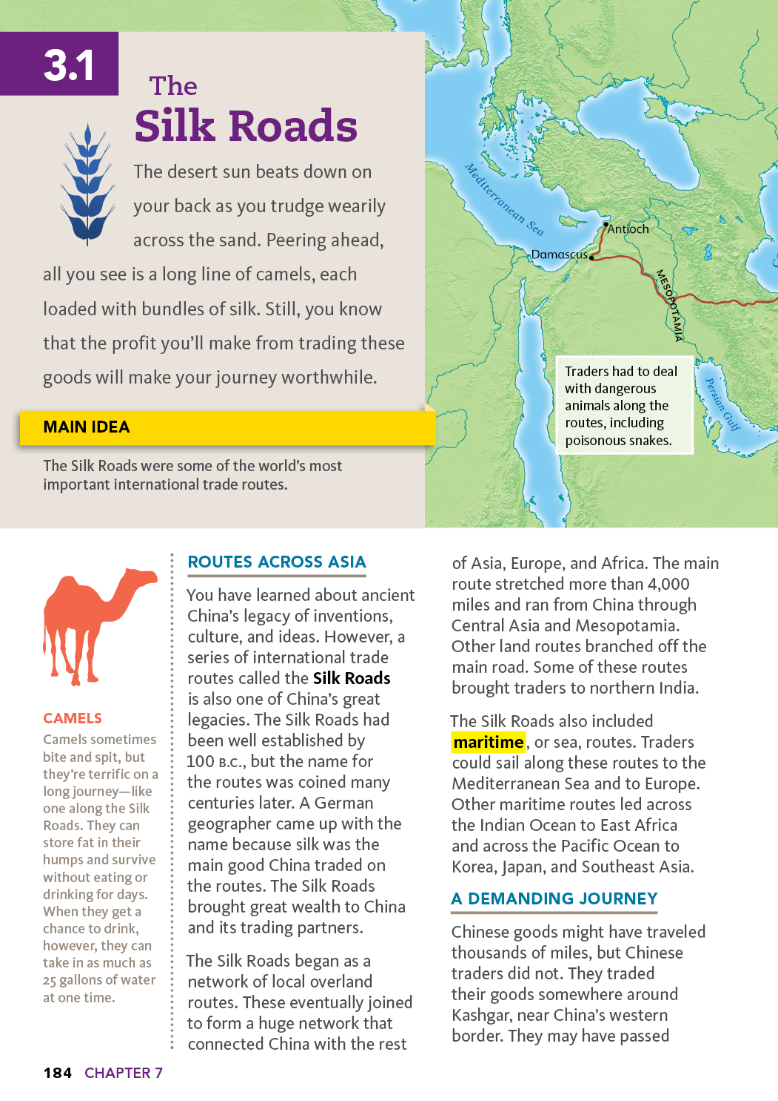

Lesson 1 Source A: Nat Geo 3.1 Silk Road (2 of 2)
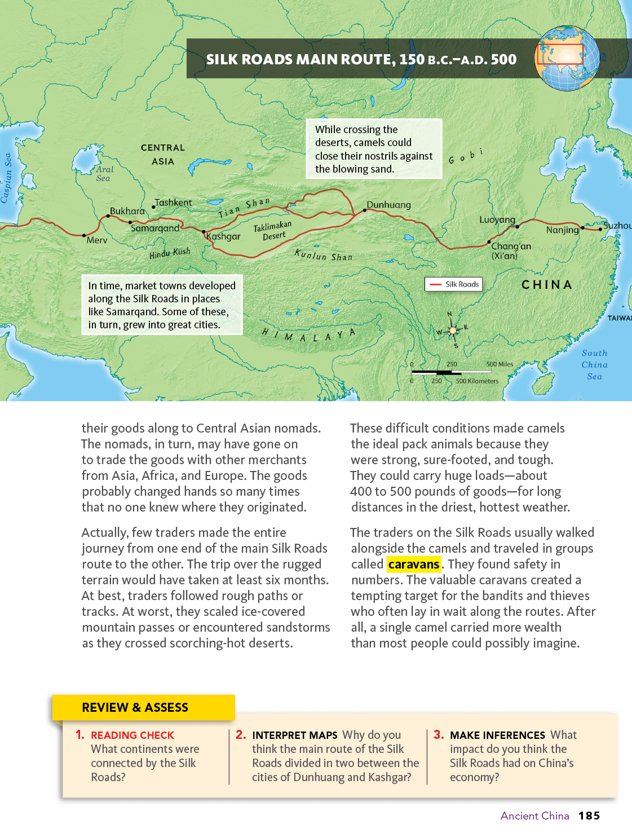

Lesson 1 Source B: Excerpt from Travels of Marco Polo | Gist Notes per Paragraph
NOTE: Marco Polo, a Venetian merchant, achieved fame from his travelogue, The Travels of Marco Polo (c. 1300), wherein he described many of the cultural and economic activities of Asian societies. Though the authenticity of his experiences in China has come into question, his book nonetheless introduced Europe to Eastern cultures. In the following excerpts, Polo provides descriptions of Silk Road trading.
The people of Tabriz [Iran] live by trade and industry; for cloth of gold and silk is woven here in great quantity and of great value. The city is so favourably situated that it is a market for merchandise from India and Baghdad, from Mosul and Hormuz, and from many other places; and many Latin merchants come here to buy merchandise imported from foreign lands. It is also a market for precious stones, which are found here in great abundance. It is a city where good profits are made by travelling merchants….
Merchants come here by ship from India, bringing all sorts of spices and previous stones and pearls and cloths of silk and of gold and elephants’ tusks and many other wares. In this city they sell them to others, who distribute them to various customers through the length and breadth of the world. It is a great centre of commerce, with many cities and towns to subordinate to it, and the capital of the kingdom….
When the traveller rides through this province [Tenduc, Northeast China] for seven days towards the east in the direction of Cathay, he finds many cities and towns inhabited by Mahometans [follower of Muhammad], idolaters, and Nestorian Christians. They live by commerce and industry, weaving the cloths of gold called nasich and nakh and silk of various types. Just as we have woolen cloths of many different types, so have they of cloth of gold and silk. They are subject to the great Khan….
Ho-kien-fu [in Cathay province, China] is a great and splendid city, lying towards the south. The people are idolaters and burn their dead. They are subject to the Great Khan and use paper money. They live by trade and industry, for they have silk in plenty. They produce cloths of gold and silk and sandal in great abundance. This city has many cities and towns subject to its dominion. Through the midst of the city flows a great river, by which quantities of merchandise are transported to Khan-balik; for they make it flow thither through many different channels and artificial waterways.

Lesson 1 Source C: BrainPOP Video Silk Road https://goo.gl/p9wCPm
Notes
2 Questions:

Ancient China Unit 2 Formative 1
Student Made Quiz

Group Member Names:

___________________________________________________________________________

Directions: You and your group will come up with 3 multiple choice questions and answers using today's sources to contribute to the class quiz. Each question must have 3 answer choices, without using none of the above OR all of the above as an option! Place a star next to the correct answer. Follow the example to complete the requirements for this assessment.

Example:

Question 1 | Which of the following continents was NOT connected by the Silk Road?
A | Africa
B | Australia
C | Europe

Question 1
A
B
C

Question 2
A
B
C

Question 3
A
B
C

Ancient China Unit 2
Lesson 2: Why was silk so important?
Learning Target:
- I can explain the silk market’s impact on Chinese and Western Societies.
Do Now: If you were to travel a long distance, would items would you bring and why?
___________________________________________________________________________________________________________________________________________________________________________________________________________________________
Notes: Go through lesson’s sources. Take notes from each source. Focus your learning towards the learning target.

Lesson 2 Source A2: Excerpt from Suleiman | Gist notes
NOTE: Suleiman, an Arab merchant, describes his travels through India and China. The excerpt below is his description of the Chinese use of silk.

Young and old Chinese all wear silk clothes in both winter and summer, but silk of the best quality is reserved for the kings….During the winter, the men wear two, three, four, five pairs of pants, and even more, according to their means. This practice has the goal of protecting the lower body from the high humidity of the land, which they fear. During the summer, they wear a single shirt of silk or some similar material.

Lesson 2 Source B2: Excerpt from “Silk Road: Connecting People and Cultures” | Gist notes
Since the concept of "Seidenstrassen" or "Silk Roads" was first invented by the German geologist and explorer Baron Ferdinand von Richthofen in 1877, the "Silk Road" has been used as a metaphor of European and Asian cultural interchange. While largely commercial, the Silk Road provided the vehicle for all sorts of creative exchange between tremendously diverse peoples and cultures.

Given the Silk Road's symbolic meaning of sharing and exchange, it is somewhat paradoxical (puzzling) that the desire to control its namesake commodity, silk, was so strong. The ancient Chinese guarded the secret of silk production for centuries. The Ottoman Turks and the Persians fought a war over it. The English and French competed to restrict its markets. But despite (regardless) of such attempts, silk moved across the planet with remarkable ease and was a vehicle of cultural creativity wherever it went. The degree of borrowing and choosing of techniques and patterns, [and] the invention and discovery of uses and styles is incredible. Every culture that touched silk added to its adornment (decoration/enhancement) of humanity.

And silk turns up everywhere — aboard medieval Viking ships sailing out of Constantinople and as kerchiefs from India (bandannas, from bandhana) around the necks of cowboys in the American West. The terms used for silk reveal its history and influences. Damask silk, referring to the style of Damascus, Syria, is actually Chinese in origin. Silk chinoiserie is not Chinese but a European imitation of Chinese style. Martha Washington wore a dress of Virginia silk to her husband's inauguration, and Native Americans learned silk embroidery to decorate traditional apparel. In the 19th century Paterson, New Jersey, of all places, declared itself "Silk City."

What is so special about silk? How did it go around the globe, and connect diverse civilizations for millennia? And what is the current significance of the Silk Road?

Chinese Silk Cultivation
Silk cultivation (development) and production is such an extraordinary process that it is easy to see why its invention was legendary and its discovery eluded (escaped) many who sought its secrets….

Silk has been long thought to be a special type of cloth; it keeps one cool in the summer and warm in the winter. It is extremely absorbent, meaning it uses color dyes much more efficiently than cotton, wool, or linen. It shimmers. It drapes upon the body particularly well. Silk is strong enough to be used for surgical sutures (stitches) — indeed, by weight it is stronger than steel and more flexible than nylon. It is also fire and rot resistant. All these natural characteristics make silk ideal as a form of adornment for people of importance, for kimonos in Japan and wedding saris in India, for religious rituals, for burial shrouds in China and to lay on the graves of Sufis in much of the Muslim world.

Early in Chinese history, silk was used to clothe the emperor, but eventually it was adopted widely throughout Chinese society. Silk proved to be valuable for fishing lines, for the making of paper, for musical instrument strings. Under the Han dynasty (206 B.C.E.-220 C.E.), silk became a great trade item, used for royal gifts and tribute. It also became a generalized medium of exchange, like gold or money. Chinese farmers paid their taxes in silk. Civil servants received their salary in silk.

Silk on the Road
…The growth of silk as a trade item both stimulated (increased) and characterized other types of exchanges during the era. Curative herbs, ideas of astronomy, and even religion also moved along the Silk Road network. Arabs traveled to India and China, Chinese to Central Asia, India, and Iran. Buddhism itself was carried along these roads from India through Central Asia to Tibet, China, and Japan. Islam was carried by Sufi teachers, and by armies, moving across the continent from Western Asia into Iran, Central Asia, China and India. Martial arts, sacred arts like calligraphy, tile making, and painting also traversed (traveled across) these roads. The Tang capital city of Chang'an, present-day Xi'an, became a cosmopolitan (worldly) city — the largest on earth at the time, peopled with traders from all along the Silk Road, as well as monks, missionaries, and emissaries from across the continent.

The Mongol Silk Road and Marco Polo
Though some new silk styles such as silk tapestry made their way eastward from Iran to Uyghur Central Asia to China, the transcontinental exchange of the Silk Road diminished in the later Middle Ages and through the period of the Christian Crusades in the Holy Land from 1096 to the mid-1200s. Yet Crusaders, returning home with Byzantine silks, tapestries, and other spoils, rekindled European interest in trade with Asia. Moorish influence in Spain also had an enormous impact. It was through Arab scholars that Europeans gained access to Indian and Chinese advances in medicine, chemistry, and mathematics, and also to ancient Greek and Roman civilizations that had survived in Arabic translations and commentaries. This flow of knowledge eventually helped to fuel the Renaissance.

With the Mongol descendants of Genghis (Chinghis) Khan in control of Asia from the Black Sea to the Pacific, a third Silk Road flourished in the 13th and 14th centuries. The emissary (representative) of King Louis IX of France, Willem van Rubruck, visited the court of the Mongol ruler in 1253, and, seeing the wealth of silks, realized that Cathay, or China, was the legendary Seres of Roman times. The Venetian Marco Polo followed.

Setting out with his uncles in 1271, Polo traveled across Asia by land and sea over a period of 24 years. The tales of his travels, narrated while a prisoner in a Genoa jail cell, spurred broad European interest in the Silk Road region. He told of the Mongols, who under Genghis and then Kublai Khan had taken over China and expanded their dominion across Asia into Central Asia, India, Iran, and Asia Minor. Polo related fantastic tales of the lands he had visited, the great sites he had seen, and the vast treasures of Asia. The 13th and 14th centuries were characterized by considerable political, commercial, and religious competition between kingdoms, markets, and religious groups across Eurasia….

During this "third" Silk Road, silk, while still a highly valued Chinese export, was no longer the primary commodity. Europeans wanted pearls and gems, spices, precious metals, medicines, ceramics, carpets, other fabrics, and lacquerware (decoratively coated items). All kingdoms needed horses, weapons, and armaments. Besides, silk production already was known in the Arab world and had spread to southern Europe. Silk weavers and traders — Arabs, "Saracens," Jews, and Greeks from Sicily and the eastern Mediterranean — relocated to new commercial centers in northern Italy. Italian silk-making eventually became a stellar Renaissance art in Venice, Florence, Genoa, and Lucca in the 14th and 15th centuries. New stylistic techniques were added, like alto-e-basso for velvets and brocades (a richly woven fabric), while old motifs (decorative designs), like the stylized Central Asian pomegranate, took on new life.

Commercial trade and competition was of great importance by the 15th century with the growth of European cities, guilds (associations of craftsmen), and royal states. With the decline of Mongol power, control over trade routes was vital. The motivation behind Portuguese explorations of a sea route to India was to secure safer and cheaper passage of trade goods than by land caravans, which were subject to either exorbitant protection fees or raiding by enemies. Indeed, it was the search for this sea route to the East that led Columbus westward to the "New World." When Vasco da Gama found the sea route to India and other Europeans subsequently opened direct shipping links with China, contact with Central Asia decreased dramatically….

Silk became both a component and a symbol of this cultural diffusion (the spreading of something widely). It was seen as a valuable index of civilization with regard to religious ritual, kingship, artistic production, and commercial activity. Silk stood for the higher things in life. It was a valuable, traded commodity, as well as a historical medium of exchange. Silk both epitomized (symbolized) and played a major role in the early development of what we now characterize as a global economic and cultural system. Europeans of the 19th century saw this new globalism not just as an interesting historical occurrence, but also as something that resonated (to have great importance) with the growing distribution of silk use and manufacturing of the time….
© Smithsonian Institute. Used with permission. http://www.festival.si.edu/past_festivals/silk_road/program_richard_kurin.aspx.

Ancient China Unit 2 Formative #2
Directions: Use your gist notes to summarize the main ideas from The Mongol Silk Road and Marco Polo section of Source B2. Summary should be written in complete sentences.
______________________________________________________________________________ ______________________________________________________________________________ ______________________________________________________________________________ ______________________________________________________________________________ ______________________________________________________________________________ ______________________________________________________________________________ ______________________________________________________________________________ ______________________________________________________________________________ ______________________________________________________________________________ ______________________________________________________________________________ ______________________________________________________________________________ ______________________________________________________________________________ ______________________________________________________________________________________________________________________________________________________________________________________________________________________________________________________________________________________________________________________________________________________________________________________________________

Ancient China Unit 2
Lesson 3: What, besides silk and other goods, was shared on the Silk Road?
Learning Target:
- I can list cultural and technological knowledge shared along the Silk Road.
Do Now: Why was silk such a special product?
___________________________________________________________________________________________________________________________________________________________________________________________________________________________________________________ _________________________________________________________________________________ _________________________________________________________________________________
Notes: Go through lesson’s sources. Take notes from each source. Focus your learning towards the learning target.

How did the Silk Road support the process of cultural diffusion?

Cultural diffusion is…

Lesson 3 Source A3: Excerpt from a Letter from Friar John of Monte Corvino to the West | Gist notes
I, Friar John of Monte Corvino, of the Order of Friars Minor [The Franciscans], departed from Tauris, a city of the Persians, in the year of the Lord 1291, and proceeded to India. And I remained in the country of India, wherein stands the church of St. Thomas the Apostle, for thirteen months, and in that region baptized in different places about one hundred persons….
I proceeded on my further journey and made my way to Cathay [China], the realm of the emperor of the Tatars who is called the Grand Khan. To him I presented the letter of our lord the pope, and invited him to adopt the Catholic faith of our Lord Jesus Christ, but he had grown too old in idolatry (worship of idols/many gods). However he bestows (grants) many kindnesses upon the Christians, and these two years past I am abiding (staying with for a long time) with him.

The Nestorians, a certain body who profess to bear the Christian name, but who deviate (move away from) sadly from the Christian religion, have grown so powerful in those parts that they will not allow a Christian of another ritual to have ever so small a chapel, or to publish any doctrine different from their own….

I have built a church in the city of Khanbaliq [modern Beijing], in which the king has his chief residence. This I completed six years ago; and I have built a bell tower to it, and put three bells in it. I have baptized there, as well as I can estimate, up to this time some 6,000 persons; and if those charges against me of which I have spoken had not been made, I should have baptized more than 30,000. And I am often still engaged in baptizing.

Also I have gradually bought one hundred and fifty boys, the children of pagan (ungodly) parents, and of ages varying from seven to eleven, who had never learned any religion. These boys I have baptized, and I have taught them Greek and Latin after our manner.

Dated at the city of Khanbaliq in the kingdom of Cathay, in the year of the Lord 1305, and on the 8th day of January.

**What is the overall subject of this source and how does that relate to the Silk Road?**

Lesson 3: Source B3: Nat Geo Article: Trade on the Silk Road (1 of 2)
Directions: Highlight key notes in each paragraph.
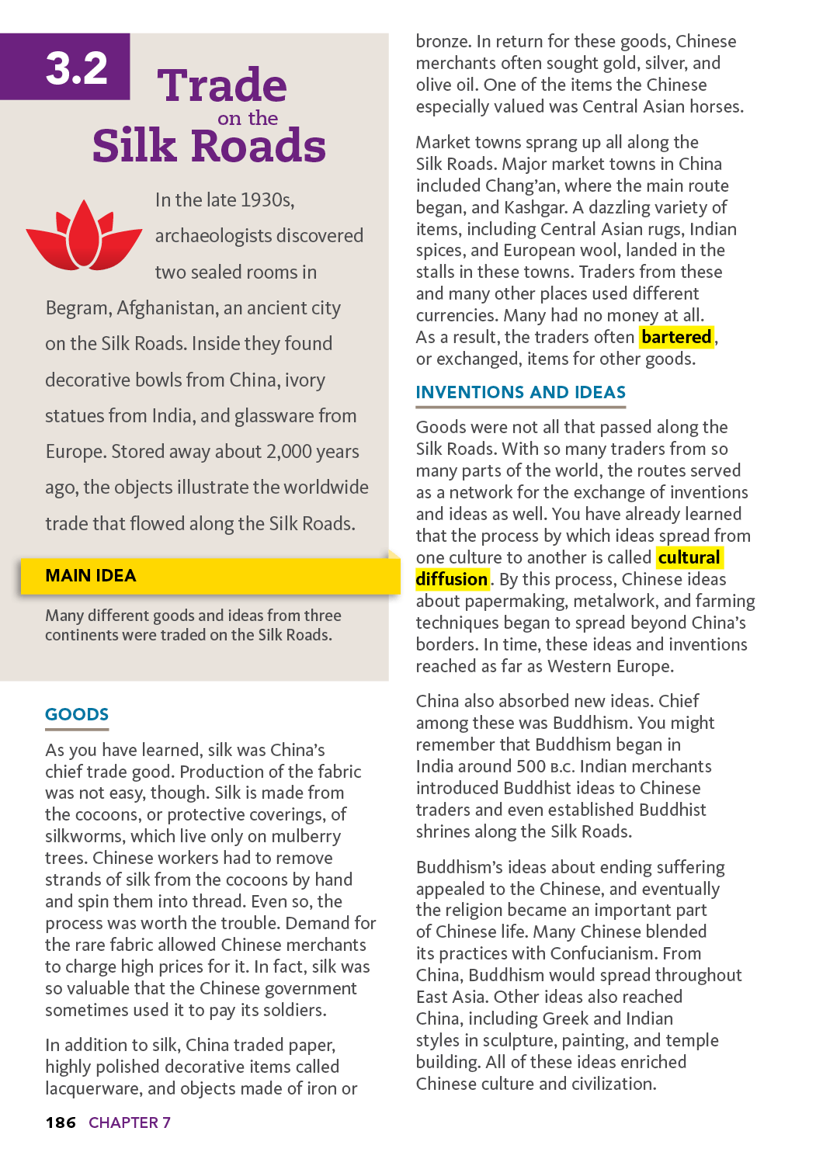

Lesson 3: Source B3: Nat Geo Article: Trade on the Silk Road (2 of 2)
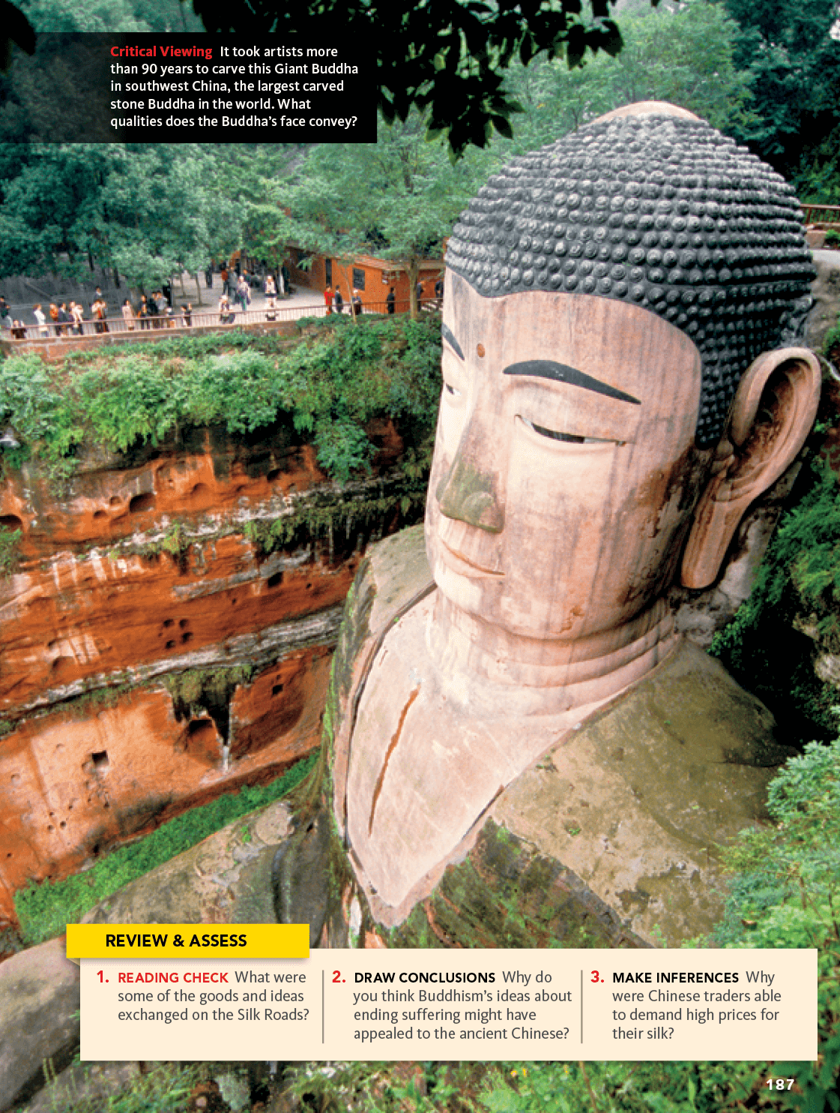
Source B3 Image Gist Notes:

Lesson 3 Source C3: Nat Geo Article: Goods From the Silk Road
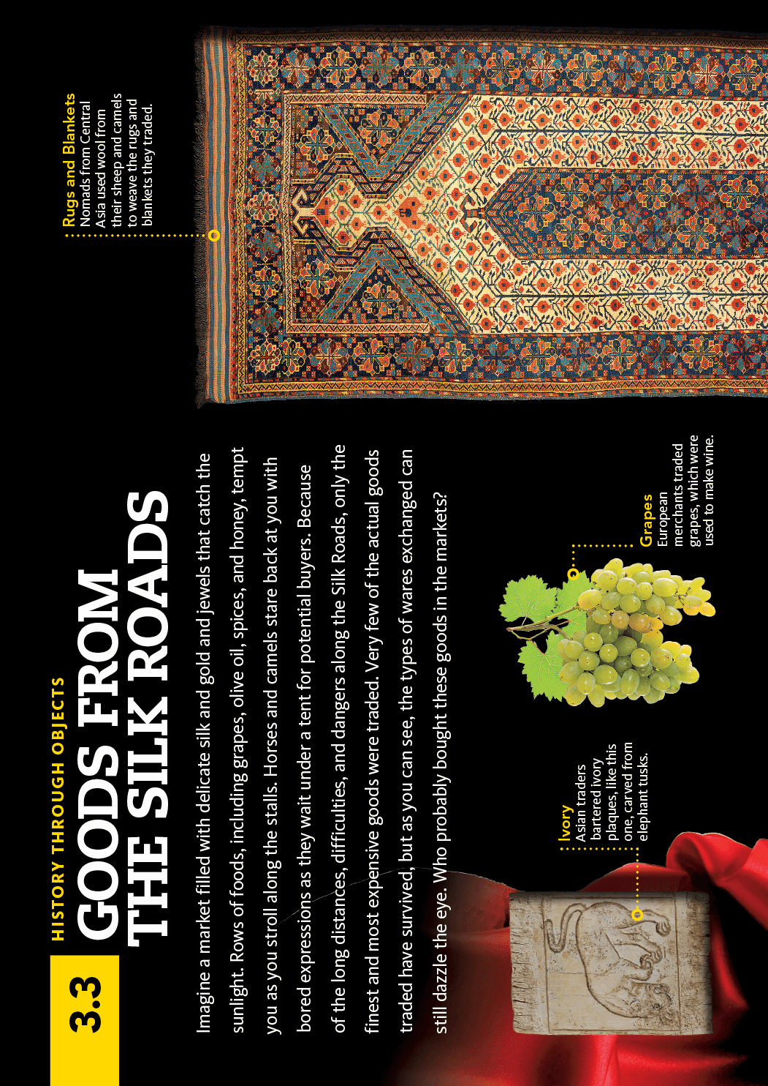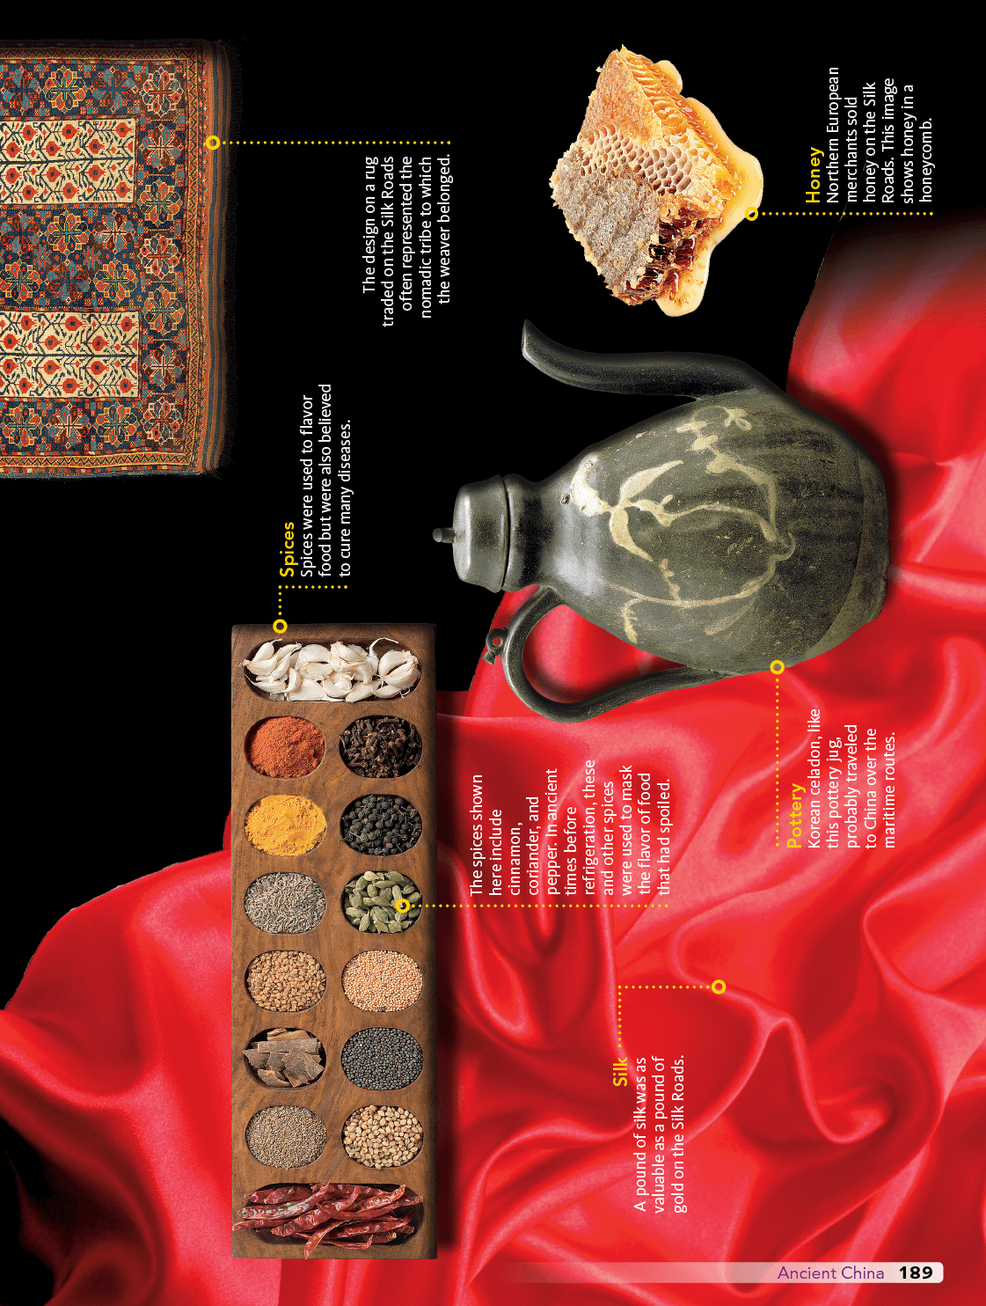
Source C3 Image GIST NOTES:

Ancient China Unit 2
Lesson 4: How did the Romans influence today's society?
Learning Target:
- I can propose a different name for the Silk Road and cite reason for my suggestion.
Do Now: How does the past events in history affect the present? Explain by giving a specific example
_____________________________________________________________________________________________________________________________________________________________________________________________________________________________________________
Notes: Go through lesson’s sources. Take notes from each source. Focus your learning towards the learning target. Record a gist of each source in the provided space.
Source A4:
___________________________________________________________________________________________________________________________________________________________________________________________________________________________________________________________________________________________________________________________________________________________________________________________________________________________________________________________________________________________________________________________________________________________________________________________________________________________________________________________________________________________________________________________________________________________________________________________________________________________________________________________________________________________________________________________________________________________________________________________________________________________________________________________________
Source B4: ____________________________________________________________________________________________________________________________________________________________________________________________________________________________________________________________________________________________________________________________
_________________________________________________________________________________________________________________________________________________________________________________________________________________________________________________________________________________________________________________________________________________________________________________________________________________________________________________________________________________________________________________________________________________________________________

Lesson 4 Source A4: Excerpt from “Following the Mythical Road”

Directions: HIGHLIGHT main ideas in each paragraph
In 1877 a German geographer of Central Asia, the Baron von Richtofen (an uncle of the First World War flying ace of the same name), coined a new term to describe the ancient caravan routes of innermost Asia: "die Seidenstrasse," or the Silk Road. News soon began to trickle back to Europe of fabulous treasures buried in the sands that had long blown over these caravan routes deep in Chinese Turkestan: silks, manuscripts, precious objects in a perfect state of preservation, cave paintings as fresh as the day they were painted, ordinary houses and elaborate temples.
By the turn of the century the archaeologists started arriving. The first objects brought back to Europe caused a sensation. Unimaginable art treasures that combined elements of Greek, Persian, Indian and Chinese civilisations perfectly preserved in the dry sands sent scholars hurrying to rewrite their books. An entirely lost ancient Indo-European language was discovered which some linguists claimed was related to Celtic. An entire lost civilisation was revealed, where Christian monks rubbed shoulders with Zoroastrian priests, Buddhist mystics and Taoist sages in perfect amicability (friendliness). The first tentative archaeological probes soon became a stampede, so that by the early years of this century British, French, German, Russian, Japanese and Americans were competing with each other to bring these treasures back to museums at home.
The Silk Road has become one of the most romantic and evocative (expressive) of images known to geography, with its great caravan cities from Damascus to Loyang; long lines of camels and remote caravanserais; impenetrable mountain barriers and endless deserts. These images were echoed in the poetry of Flecker and Coleridge and a vast array of travel writing from Marco Polo to Colin Thubron. This writing has conjured (called upon) up the picture of a great international and multinational highway where Romans, Chinese, Indians and Tartars freely met and intermingled. The Silk Road has become one of the best known "facts" of Asian geography.
Such images could not be further from the truth. For such is the power of the Silk Road today that few realise the whole thing is a modern fabrication. The first "fact" one must learn about the Silk Road is that there was no such thing. The Baron von Richtofen was the first person to use the name, yet the one person now associated with the Silk Road more than anybody else, Marco Polo, would never have heard of it.
Edward Gibbon, writing of Roman trade with the East over 200 years ago, makes no reference to any purported "Silk Road" or route nor even any reference to China. Eastern trade was seen solely in terms of Arabia and India, China is not mentioned, and silk only referred to in reference to India and the spice trade.
Arguably the greatest "Silk Road" explorer, the British archaeologist Sir Aurel Stein -- who excavated the ancient sand-buried ruins of Chinese Turkestan and publicised them to astonished audiences -- never once used the term….
Hence when we turn to India, there is copious (lots of) evidence for sea trade with the West.… Items imported from India were mainly luxury goods, as only their high retail value in western markets could justify the high cost of transporting them across such vast distances. They included silk, pearls, precious woods, ivory, precious stones, and occasionally exotic animals such as tigers and leopards. Above all it was spices, such as cinnamon, balsam, cassia, cardamom and pepper. Spices were always the main import from the East, and especially pepper. Silk was never a major commodity, despite the high profile given to it in modern accounts.
In searching for evidence for the Silk Road and other trade routes one senses that perhaps we have inherited a little of our Victorian forebears' obsession with routes, dominated as it is by concerns with wheeled transport. In actual fact, established routes -- lines drawn with such confidence across maps -- were largely non-existent in ancient times. Outside the Roman and Persian Empires there were never roads or even routes in an organised sense. Such routes as did exist went simply from city to city or, at best (and more rarely), from country to country. There were never any transcontinental routes. Any ancient route, therefore, was at best simply a broad channel of communications across a region. It consisted of a series of short irregular hops, rarely following any fixed or time-worn pathway….
The arrival of silk in the West was more a result of a series of accidents rather than organised trade. When it did come, it was via India and the sea routes -- and certainly not overland. Both ancient Rome and China had only the haziest notions of each other's existence and, more importantly, even less interest.
The greatest value of the Silk Road to geography is as a lesson -- and a very important one at that -- in how quickly and how thoroughly a myth can become enshrined as unquestioned fact.
Used with permission. © Syon Geographical, Ltd.

Lesson 4 Source B4: Excerpt from “The Silk Road in World History: A Review Essay”

Directions: HIGHLIGHT main ideas in each paragraph
THE SILK ROAD AS A HISTORIOGRAPHICAL CONSTRUCT (THEORY)
Silk Road? Silk Roads? Silk Routes? Which is it and why? Today, most Anglophone (English) scholars who write books and articles that are focused exclusively on these trans-Eurasian caravan routes that crisscrossed Eurasia’s heartland in Late Antiquity and following prefer the evocative and admittedly misleading singular “Silk Road.” Yet many (but certainly not all) world historians, whose historiographical vision impels (makes) them to view the past on a grand scale, choose to use the more correct plural form. Likewise, some contemporary world historians, who see the sea lanes of the Indian Ocean, the Red Sea, the Mediterranean, and similar avenues of maritime transportation as integral (essential) parts of the network of long-distance interchange in Late Antiquity (ancient times) and following, favor the term “Silk Routes,” which lacks connotations of singularity and terrestriality (occurring on land). French historians almost universally favor the singular and romantic la route de soie (the Silk Route). German scholars likewise largely prefer the traditional and singular die Seidenstrasse (the Silk Road). It is significant, and tells us quite a bit about how old historical labels remain in vogue (popularity) long after their accuracy has been questioned, that although historians now agree that silk was only one of many valuable items transported and traded along the Silk Road and also that, in the final analysis, the most historically important “commodities” carried along these routes were ideas and culture and not goods, we still preface Road, Roads, or Routes with “Silk.”
…We have to ask ourselves, are the terms “Silk Road,” “Silk Roads,” and “Silk Routes” valid today, given the expansion of our knowledge and perspectives over the past 137 years since Baron Ferdinand von Richthofen gave life to these terms and concept? This writer’s answer is a resounding “Yes!” There is no good reason to abandon these evocative, albeit inexact, terms. History without romance is sterile. Moreover, it is clear that the current institutionalization of Silk Road studies and its expanse on a global scale due to digital technology ensure that we are now in an era of profound advancement in our understanding of the Silk Road. The Silk Road lives on.
Courtesy of A. J. Andrea.

Ancient China Unit 2
Lesson 5: Should We Call It the “Silk Road”??
Learning Target:
- I can make a claim using relevant evidence from multiple historical sources.
Do Now: If you were forced to rename the Silk Road, what would you call it and why?
_____________________________________________________________________________________________________________________________________________________________________________________________________________________________________________

Gathering & Using Evidence: Use the resources and your understanding from the past lessons to answer the question below and fill out the chart. Respond in complete sentences and use 3 different sources.
Should We Call the trade route the “Silk Road”??
Initial Claim:
What is your opening claim to the prompt? This claim should appear in the opening section of your argument.
Evidence #1
What evidence do you have from the sources you investigated to support your initial claim? Cite your sources.
Reasoning #1
Explain your evidence and how it supports your initial claim.
Evidence #2
What evidence do you have from the sources you investigated to support your initial claim? Cite your sources.
Reasoning #2
Explain your evidence and how it supports your initial claim.
Evidence #3
What evidence do you have from the sources you investigated to support your initial claim? Cite your sources.
Reasoning #3
Explain your evidence and how it supports your initial claim.
Pulling It Together:
What is your overall understanding of the compelling question? This should be included in your conclusion.

Ancient China Unit 2
Lesson 6: Drafting and Peer Review
Learning Target:
- I can use ideas from my graphic organizer to construct a response.
- I can give my peers feedback on their writing: claim, evidence, and reasoning.
- I can check if my peers are meeting an assignment requirements.
Do Now: Think about the feedback you’ve been receiving. What type of feedback do you find the most helpful?
_____________________________________________________________________________________________________________________________________________________________________________________________________________________________________________

Assignment Rubric This is the rubric for today's assignment. Preview and use this in drafting and peer editing.
Rubric Categories | 4 | 3 | 2 | 1 | 0
CLAIM (W.6.2) | Claim is clearly communicated and rephrases the question. Uses complete sentence and responds to the writing prompt.  (1-2 sentence) | Claim sentence responds to the writing prompt, but may not be in complete sentence. (1-2 sentence) | Claim sentence responds to the writing prompt, but is incorrect.(1 sentence) | Claim sentence responds does not respond to to the writing prompt. Or may be confusing and unclear. (0-1 sentence) | Claim is missing
EVIDENCE (W.6.2) | 3 pieces of evidence (direct quote) is strongly integrated, relevant, and specific. All evidence is cited correctly.  (3-2 sentences) | 2 pieces of evidence (direct quote) is integrated, relevant, and specific. Evidence is missing citation.  (2 sentences) | Some evidence (direct quote) may be appropriate, but paraphrased. OR only 1 piece of evidence is provided.  (1-2 sentences) | -Evidence(direct quote) is minimal or irrelevant.  -Evidence may be pulled from the wrong source.  (0-1 sentences) | No Evidence Provided
REASONING (W.6.2) | Reasoning uses details to clearly explains how the evidence provided supports or shows the claim. Uses complete sentences.  (2-3 sentences) | Reasoning explains how the evidence supports the claim.  (2 sentences) | Student attempts to explain how the evidence supports the claim, but is unclear or confusing. (1-2 sentences) | Very little reasoning is provided. (0-1 sentences) | Reasoning is not provided.

Ancient China Unit 2 - Formative #3 (Rough draft)

Using Evidence: Use your ideas in the graphic organizer from Lesson 5 to form a response to the writing prompt. Use the CLAIM, EVIDENCE, REASONING writing strategy to respond.
Minimum 1 paragraph. Use complete sentences and you must use 3 different sources!
Writing Prompt : Should We Call the trade route the “Silk Road”??

____________________________________________________________________________________________________________________________________________________________________________________________________________________________________________________________________________________________________________________________________________________________________________________________________________________________________________________________________________________________________________________________________________________________________________________________________________________________________________________________________________________________________________________________________________________________________________________________________________________________________________________________________________________________________________________________________________________________________________________________________________________________________________________________________________________________________________________________________________________________________________________________________________________________________________________________________________________________________________________________________________________________________________________________________________________________________________________________________________________________________________________________________________________________________________________________________________________________________________________________________________________________________________________________________________________________________________________________________________________________________________________________________________________________________________________________________________________________________________________________________________________________________________________________________________________________________________________________________________________________________________________________________________________________________________________________________________________________________________________________________________________________________________________________________________________________________________________________________________________________________________________________________________________________

Peer Feedback: Get peer feedback from 2 peers in your group. Ask them to help you check if you met ALL the requirements. They should also check your claim, evidence, and reasoning writing structure. Also ask them to include anything else you could add to improve your response.
1st Peer Review done by:  ______________________  ______________________ | Suggestions:  -  -  -  Positive Comment(s):  -  -  -
2nd Peer Review done by:  ______________________  ______________________ | Suggestions:  -  -  -  Positive Comment(s):  -  -  -

Ancient China Unit 2 - Summative Assessment FINAL DRAFT

Using Evidence: Use your ideas in the graphic organizer from Lesson 5 to form a response to the writing prompt. Use the CLAIM, EVIDENCE, REASONING writing strategy to respond.
Minimum 1 paragraph. Use complete sentences and you must use 3 different sources!
Writing Prompt : Should We Call the trade route the “Silk Road”??

____________________________________________________________________________________________________________________________________________________________________________________________________________________________________________________________________________________________________________________________________________________________________________________________________________________________________________________________________________________________________________________________________________________________________________________________________________________________________________________________________________________________________________________________________________________________________________________________________________________________________________________________________________________________________________________________________________________________________________________________________________________________________________________________________________________________________________________________________________________________________________________________________________________________________________________________________________________________________________________________________________________________________________________________________________________________________________________________________________________________________________________________________________________________________________________________________________________________________________________________________________________________________________________________________________________________________________________________________________________________________________________________________________________________________________________________________________________________________________________________________________________________________________________________________________________________________________________________________________________________________________________________________________________________________________________________________________________________________________________________________________________________________________________________________________________________________________________________________________________________________________________________________________________________

