Name _______________________

Ancient China
Unit1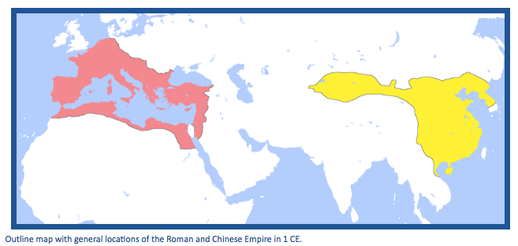
Essential Question:
Did the Chinese and Romans Know Each Other?

Ancient China Unit 1 - Lesson 1
Day 1: Supporting Question 1: Where were the Roman and Chinese Empires located?
Learning Target:
- I can write a description of the relative locations and geographic features of the Roman and Chinese Empires.
Do Now- Part 1: Describe and create a map showing your route from your home to school.
_________________________________________________________________________
_________________________________________________________________________
_________________________________________________________________________ _________________________________________________________________________
_________________________________________________________________________
_________________________________________________________________________

Do Now- Part 2: Fill in the chart with any information you know about both empires:
What I Know about the ROMAN EMPIRE | What I Know about ANCIENT CHINA

Day 1 :Source A: Outline map with general locations of the Roman and Chinese Empires
NOTE: On the map below, the Roman Empire is highlighted in red and the Chinese empire is highlighted in yellow.

What do you notice and wonder about the map? Include the themes of geography in your observations and questions. Use complete sentences.
Notice | Wonder
1. | 1.
2. | 2.
3. | 3.
4. | 4.
5. | 5.

Day 1: Source B: Detailed map of Roman and Chinese Empires
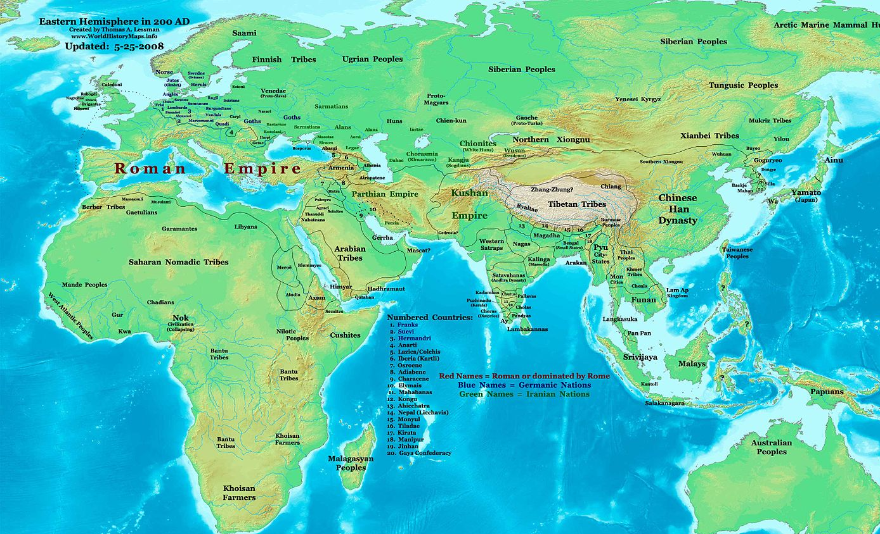
What do you notice and wonder about the map? Include the themes of geography in your observations and questions.Use complete sentences.
Notice | Wonder
1. | 1.
2. | 2.
3. | 3.
4. | 4.
5. | 5.

Ancient China Unit 1 - Lesson 2
Day 2: Supporting Question 1: Where were the Roman and Chinese Empires located?
Learning Target:
- I can write a description of the relative locations and geographic features of the Roman and Chinese Empires.
Do Now: What geographic theme do you think is the most important for the development of a powerful civilization? Justify your answer.
_______________________________________________________________________________________________________________________________________________________________________________________________________________________________________ _______________________________________________________________________________________________________________________________________________________________________________________________________________________________________

Location of empires: Circle the relative location of the Roman Empire and color in China
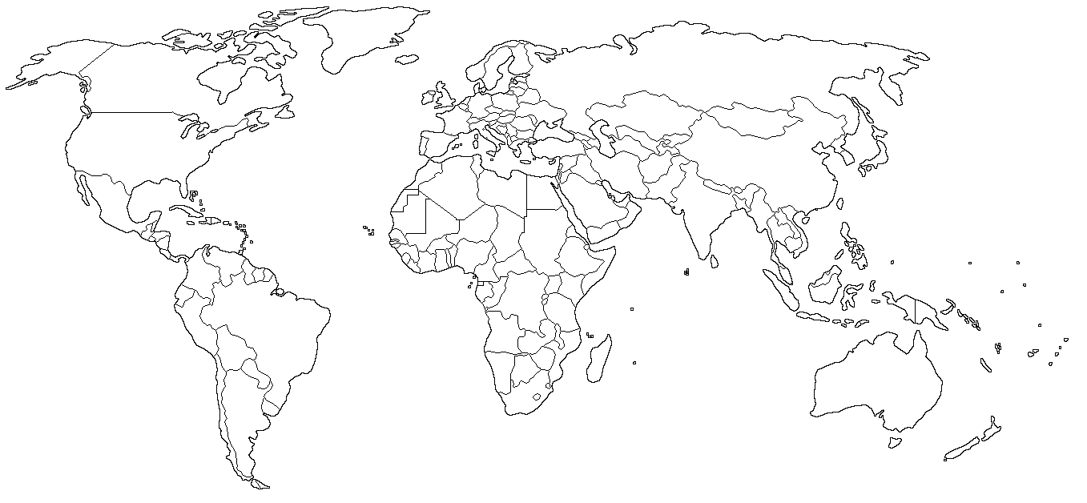

Video Notes: Complete the following notes based on the video.
1) The ____________________________ forms part of China’s natural border to the West.
• What is a plateau?________________________________________________
• Why is a plateau a natural barrier?___________________________________

2.) The ____________________________ are some of the largest mountains in the world.
• Tallest mountain is:______________________________________________
• Height:________________________________________________________
• Mountains are natural barriers because:______________________________

3.) The _____________________________ is a vast area stretching from Mongolia into China.
• A desert receives less than __________ inches of rain a year.
• Difficult to cross with a large _____________________________.
• Deserts are natural barriers because:__________________________________

4.) What formed the natural barrier to the East? _______________
• Oceans are natural barriers because:________________________________
How did geography influence China’s development? Identify examples.
HELP | HURT
1.  2. | 1.  2.

Two Major Rivers in China
- The Huang He River (also known as the Yellow River) is sometimes called the _____________________________ because of the destruction from ________________, yet people continued to live near the river because of the ____________________________.
- ____________________________ (also known as the Chang River) is the longest river in Asia and the third longest in the world.
- ______________________ is fertile yellow soil that is blown off the plains into the river and deposited back on land during a flood to make fertile soil.

Ancient China Unit 1, Lesson 1
Formative Assessment #1
Interpreting Evidence:
- Based on your notices from Sources A and B and your video notes, write a description of the relative locations and geographic features of the Roman and Chinese Empires. 1 paragraph minimum. Use RACE strategy to format your response:
-Rewrite the question into a topic sentence
-Answer all parts of the question with a claim
-Cite evidence from the text(s)
-Explain how your evidence supports your claim
The relative location of the Roman and Chinese empires is that they were on different _____________________________. Source A clearly shows that the Roman empire was located in __________________________ and _______________________, while the Chinese empire was located in ________________________. Source B and the video show that the Chinese empire had various geographical features that __________________________________________________________________, such as, ____________________________________, ____________________________________, ____________________________________, ____________________________________. Source B shows that the Roman empire had various geographical features such as, _____________________________________________________________ and _____________________________________________________________________ that ________________________________________________________________________. 2) Based on the evidence so far, do you think the Chinese knew about the Romans? Yes or no and why? Refer to details from at least two sources (A, B, or video notes) to support your answer and use the RACE strategy to format your response.
The Chinese did/did not know about the Romans because _________________________________________________________________________. Source _______ shows that ___________________________________________________ _________________________________________________________________________. Source _______ shows that __________________________________________________ _________________________________________________________________________.

Ancient China Unit 1 - Lesson 3
Day 3&4: Supporting Question 2: What did the Chinese know about the West?
Learning Target:
- I can start a T-chart that compares what the Romans and Chinese knew about each other.
Do Now: What tools would you use to get to a place you may have never been, without using technology (for example, Google maps or your mobile device)?
__________________________________________________________________________________ ____________________________________________________________________________________________________________________________________________________________________
Create a list of I notice and I wonder statements about the map.

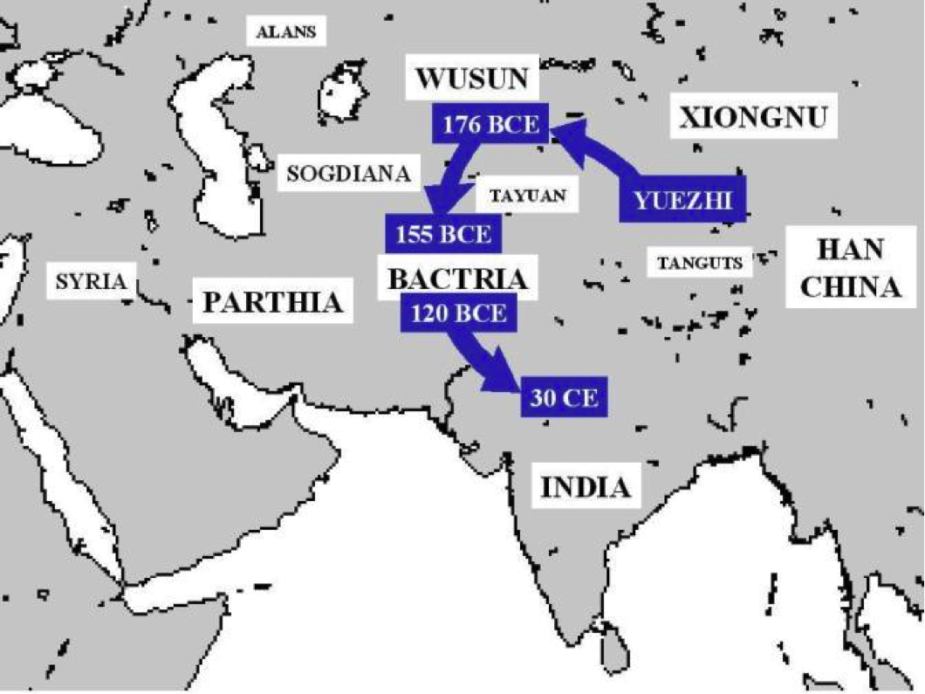

I Notice… I Wonder...

Directions: Write a gist for each paragraph in this column | Supporting Question 2: Source A2: Sima Qian, description of Zhang Qian’s travels in the West, Records of the Great Historian and Travels of Zhang Qian (excerpts), 130 BCE
NOTE: Sima Qian is considered by many to be China’s first and greatest historian. He wrote the following account of the accomplishments of Zhang Qian, who was one of China’s first explorers into the West. Zhang Qian explored territory to the west of China reaching as far as modern day Mesopotamia. Zhang Qian described a people he met called the Yuezhi who lived in an area west of India that was well known to the Romans. Zhang Qian also explored Mesopotamia, which was later governed by Rome. Some scholars credit Zhang Qian’s explorations as establishing the knowledge that would be needed to create Silk Roads.
“The Great Yuezhi live some 2,000 or 3,000 li [1,000 or 1,200 kilometers] west of Dayuan, north of the Gui (Oxus) river. They are bordered to the south by Daxia [in modern-day Afghanistan], on the west by Anxi (Parthia) [in modern-day Iran], and on the north by Kangju [in modern-day Tajikistan]. They are a nation of nomads, moving place to place with their herds and their customs are like those of the Xiongnu. They have some 100,000 or 200,000 archer warriors." (Shiji, 123, Zhang Qian quote, trans. Burton Watson)
“Daxia is situated over 2,000 li [1,000 kilometers] southwest of Dayuan (Ferghana), south of the Gui (Oxus) river. Its people cultivate the land, and have cities and houses. Their customs are like those of Dayuan. It has no great ruler but only a number of petty chiefs ruling the various cities. The people are poor in the use of arms and afraid of battle, but they are clever at commerce. After the Great Yuezhi moved west and attacked and conquered Daxia, the entire country came under their sway. The population of the country is large, numbering some 1,000,000 or more persons. The capital is Lanshi (Bactra) where all sorts of goods are bought and sold." (Shiji, 123, Zhang Qian quote, translation Burton Watson).
“Southeast of Daxia is the kingdom of Shendu (India)....Shendu, they told me, lies several thousand li southeast of Daxia (Bactria). The people cultivate the land and live much like the people of Daxia. The region is said to be hot and damp. The inhabitants ride elephants when they go in battle. The kingdom is situated on a great river (Indus)" (Shiji, 123, Zhang Qian quote, trans. Burton Watson).
“Anxi is situated several thousand li west of the region of the Great Yuezhi. The people are settled on the land, cultivating the fields and growing rice and wheat. They also make wine out of grapes. They have walled cities like the people of Dayuan (Ferghana), the region contains several hundred cities of various sizes. The coins of the country are made of silver and bear the face of the king. When the king dies, the currency is immediately changed and new coins issued with the face of his successor. The people keep records by writing on horizontal strips of leather. To the west lies Tiaozhi (Mesopotamia) and to the north Yancai and Lixuan (Hyrcania)." (Shiji, 123, Zhang Qian quote, trans. Burton Watson).
“Tiaozhi (Mesopotamia) is situated several thousand li west of Anxi (Parthia) and borders the Western Sea (Persian Gulf/ Mediterranean?). It is hot and damp, and the people live by cultivating the fields and planting rice….The people are very numerous and are ruled by many petty chiefs. The ruler of Anxi (Parthia) give orders to these chiefs and regards them as vassals." (Shiji, 123, Zhang Qian quote, trans. Burton Watson).

Directions: Write a gist for each paragraph in this column | Supporting Question 2: Source B2: Fan Ye, description of the West based on travels of Gan Ying in 97 CE, Hou Hanshu or History of the Han (excerpts), 5th century CE
NOTE: The excerpts below come from the Hou Hanshu (also known as History of the Later Han), which was compiled by historian Fan Ye in the 5th century CE. Fan Ye followed in the tradition of Sima Qian. Fan Ye wrote a description of the Roman Empire that he created in 97 CE based on the travels of Gan Ying.
Section 11 – The Kingdom of Da Qin (the Roman Empire)
The Kingdom of Da Qin (the Roman Empire) is also called Lijian. As it is found to the west of the sea, it is also called the Kingdom of Haixi (Egypt). Its territory extends for several thousands of li [three li equals one mile]. It has more than four hundred walled towns. There are several tens of smaller dependent kingdoms. The walls of the towns are made of stone….
The people of this country are all tall and honest. They resemble the people of the Middle Kingdom and that is why this kingdom is called Da Qin [literally, ‘Great China’].
Section 12 – The Products of Da Qin (the Roman Empire)
This country produces plenty of gold, silver, and precious jewels, luminous jade, ‘bright moon pearls,’ fighting cocks, rhinoceroses, coral, yellow amber, opaque glass, whitish chalcedony, red cinnabar, green gemstones, drawn gold-threaded and multi-coloured embroideries, woven gold-threaded net, delicate polychrome silks painted with gold, and asbestos cloth….
The people of this country are honest in business; they don’t have two prices. Grain and foodstuffs are always in good supply. The resources of the state are abundant. When envoys from a neighbouring kingdom arrive at their border, they use the courier stations to get to the royal capital, and when they arrive, they give them gold coins.
The king of this country always wanted to send envoys to the Han, but Anxi (Parthia), wishing to control the trade in multicolored Chinese silks, blocked the route to prevent [the Romans] getting through [to China].

Directions: Write a gist for each paragraph in this column | Supporting Question 2: Source C2: Yu Huan, description of Romans, Weilue or Brief History of the Wei (excerpts), 265 CE
NOTE: Weilue, or the brief history of the Wei, was written by Yu Huan. Wei or Cao Wei was one of three states in that vied for power in the Three States Period of Chinese dynastic history (220-280 CE). In this passage Yu Huan draws on several sources to describe Romans.
This country (the Roman Empire) has more than four hundred smaller cities and towns. It extends several thousand li in all directions. The king has his capital (that is, the city of Rome) close to the mouth of a river (the Tiber). The outer walls of the city are made of stone.
…The ruler of this country is not permanent. When disasters result from unusual phenomena, they unceremoniously replace him, installing a virtuous man as king, and release the old king, who does not dare show resentment.
The common people are tall and virtuous like the Chinese, but wear hu (‘Western’) clothes. They say they originally came from China, but left it.
They have always wanted to communicate with China but, Anxi (Parthia), jealous of their profits, would not allow them to pass (through to China).

Ancient China Unit 1, Lesson 3
Formative Assessment #2

Comparisons and Contextualization: Use Sources A2, B2, and C2 to fill out the T-chart that compares what the Romans and Chinese knew about each other.
What did the Chinese know about the West?
Respond in complete sentences | Cite your Source
1.

2.

3.

4.

5.

6.

7.

8.

Ancient China Unit 1 - Lesson 4
Day 5: Supporting Question 3: What did the Romans know about the East?
Learning Target:
- I can complete a T-chart that compares what the Romans and Chinese knew about each other.
Do Now: Why do we study and travel to other places and countries?
________________________________________________________________________________________________________________________________________________________________________________________________________________________________________________________________________________________________________________________________________

Directions: Write a gist for each paragraph in this column | Supporting Question 3: Source A3: Pliny the Elder, description of China, Natural History (excerpts), 77 CE
NOTE: This text appeared in the Roman writer Pliny the Elder’s Natural History VI, 54. Natural History was a far-reaching effort by Pliny the Elder to describe the world. He wrote several volumes on geography, which included the following text about silk production in China. Pliny the Elder refers to the people who created silk as Seres

The Seres are famous for the woolen substance obtained from their forests; after a soaking in water they comb off the white down of the leaves….So manifold is the labour employed, and so distant is the region of the globe drawn upon, to enable the Roman maiden to flaunt transparent clothing in public.

Directions: Write a gist for each paragraph in this column | Supporting Question 3: Source B3: Claudius Ptolemy, a description and map of the Asia, Geography (excerpt), 150 CE
NOTE: Ptolemy was an Egyptian-born mathematician and geographer who lived in the city of Alexandria during the Roman Empire. One of Ptolemy’s greatest works was his atlas titled Geography. In this book, Ptolemy published some of the first western descriptions and maps of China.

The inhabited part of our earth is bounded on the east by the Unknown Land which lies along the region occupied by the easternmost nations of Asia Major, the Sim and the nations of SERICE; and on the south likewise by the Unknown Land which shuts round the Indian Sea, and encompasses that Ethiopia to the south of Libya which is called the land of Agisymba; to the west by the Unknown Land which embraces the Ethiopic Gulf of Libya, and then by the Western Ocean which lies along the most westerly parts of Libya and of Europe; and on the north by that continuation of the same ocean which encircles the Britannic Isles and the most northerly parts of Europe, and which goes by the names of Duecalydonian and Sarmatie, and by an Unknown Land which stretches along the most northerly parts of Asia Major, viz., Sarmatia, Scythia, and Serice.
NOTE: This map by 2nd century geographer Ptolemy represented China as two places. Ptolemy called the northern part of China, the Serica or the Land of Silk. Below Serica was Sinae, or the Land of Qin.
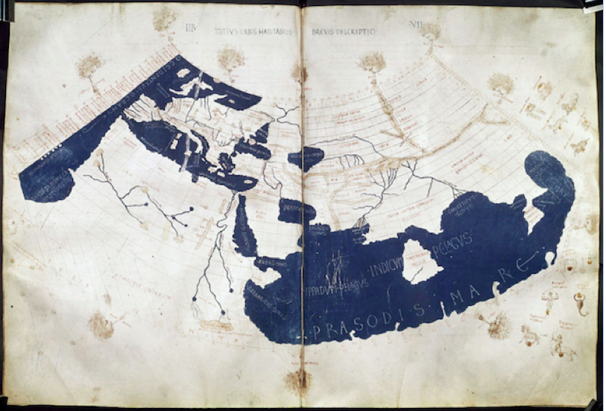
I notice...
1.
2.

Ancient China Unit 1, Lesson 4
Formative Assessment #3
Comparisons and Contextualization: Use Source A3 and B3 to fill out half of the T-chart that compares what the Romans and Chinese knew about each other.
What did the Romans know about the East?
Respond in complete sentences | Cite your Source
1.

2.

3.

4.

5.

6.

7.

8.

Ancient China Unit 1 - Lesson 5
Day 7: Supporting Question 4: How did the Chinese and Romans interact with one another?
Learning Target:
- I can explain how Romans and Chinese interacted.
Do Now: People often say that the United States is a melting pot of cultures. What foods, ideas, and traditions show how the United States is a mix of many cultures?
___________________________________________________________________________________________________________________________________________________________________________________________________________________________________________________

Supporting Question 4: Source A4: 1st and 2nd Century CE global trade route maps
Map 1: Map illustrating various global trade route maps, “Trade Routes and Great Empires of the First Century A.D.” 2010
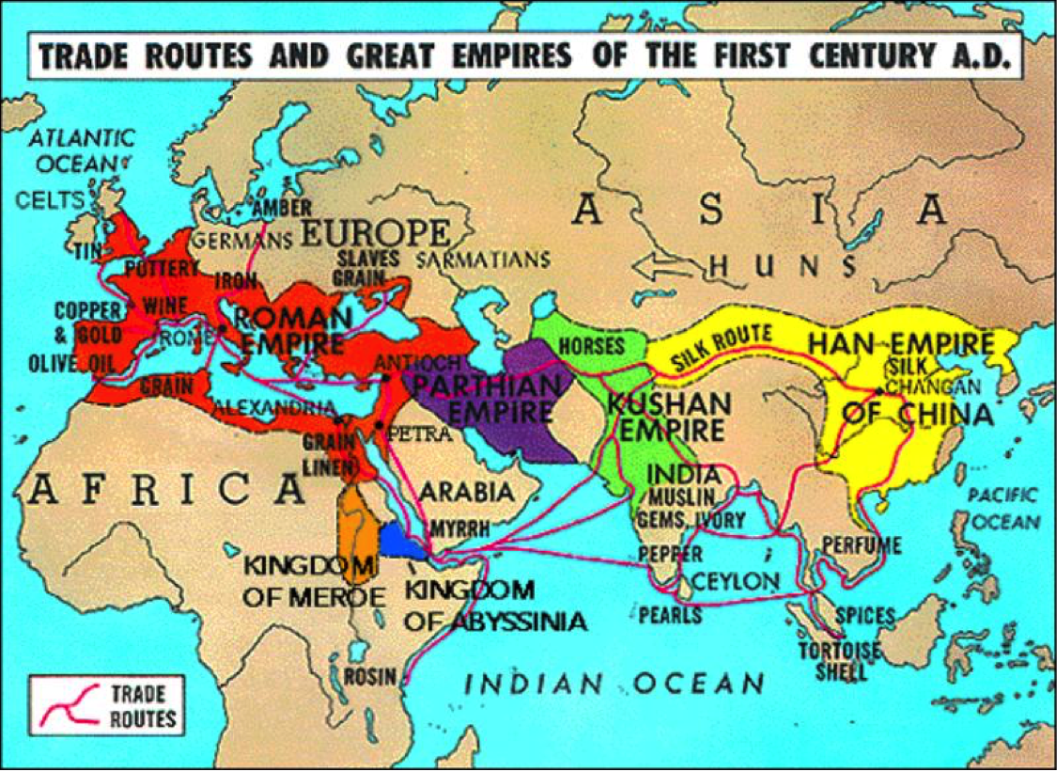
I Notice | I Wonder
1.  2.  3. | 1.  2.  3.

Supporting Question 4: Source B4: 1st and 2nd Century CE global trade route maps
Map 2: Map illustrating trade routes in the Roman Empire, “Roman Trade Network in 180 AD”
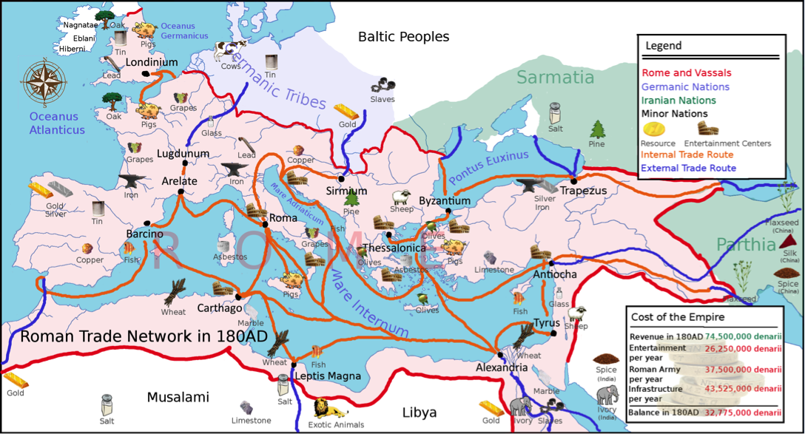
I Notice | I Wonder
1.  2.  3. | 1.  2.  3.

Name:_______________________________________________ DATE:__________________

Ancient China Unit 1
Formative #4
Write a Claim: Citing sources A4 and B4, explain how the ancient Chinese and Romans could have interacted with one another? Use RACE strategy to format your response:
-Rewrite the question into a topic sentence
-Answer all parts of the question with a claim
-Cite evidence from the text(s)
-Explain how your evidence supports your claim
________________________________________________________________________________________________________________________________________________________________________________________________________________________________________________________________________________________________________________________________________________________________________________________________________________________________________________________________________________________________________________________________________________________________________________________________________________________________________________________________
________________________________________________________________________________ ________________________________________________________________________________________________________________________________________________________________
________________________________________________________________________________ ________________________________________________________________________________

NAME:_______________________________________________DATE:_________________
Ancient China Unit 1 - Lesson 6
Day 8: Summative Performance Task (1 of 2 days)
Learning Target:
- I can construct an argument (e.g., a speech, movie, poster, or essay) that explains to what extent the Chinese and Romans knew and interacted with each other using specific claims and relevant evidence from historical sources.
Do Now: What makes a strong argumentative essay?
____________________________________________________________________________________________________________________________________________________________________

Look at the rubric below. Which category do you struggle with the most? How do you plan to improve on that category in your writing today?
________________________________________________________________________________________________________________________________________________________________________________________________________________________________________________________________________________________________________________________________________

Assignment Rubric This is the rubric for today's assignment. Preview and use this in drafting and peer editing.
Rubric Categories | 4 | 3 | 2 | 1 | 0
CLAIM (W.6.2) | Claim is clearly communicated and rephrases the question. Uses complete sentence and responds to the writing prompt.  (1-2 sentence) | Claim sentence responds to the writing prompt, but may not be in complete sentence. (1-2 sentence) | Claim sentence responds to the writing prompt, but is incorrect.(1 sentence) | Claim sentence responds does not respond to to the writing prompt. Or may be confusing and unclear. (0-1 sentence) | Claim is missing
EVIDENCE (W.6.2) | 2 pieces of evidence (direct quote) is strongly integrated, relevant, and specific. All evidence is cited correctly.  (2 sentences) | 2 pieces of evidence (direct quote) is integrated, relevant, and specific. Evidence is missing citation.  (2 sentences) | Some evidence (direct quote) may be appropriate, but paraphrased. OR only 1 piece of evidence is provided.  (1-2 sentences) | -Evidence (direct quote) is minimal or irrelevant.  -Evidence may be pulled from the wrong source.  (0-1 sentences) | No Evidence Provided
REASONING (W.6.2) | Reasoning uses details to clearly explains how the evidence provided supports or shows the claim. Uses complete sentences.  (2-3 sentences) | Reasoning explains how the evidence supports the claim.  (2 sentences) | Student attempts to explain how the evidence supports the claim, but is unclear or confusing. (1-2 sentences) | Very little reasoning is provided. (0-1 sentences) | Reasoning is not provided.

Gathering & Using Evidence: Use the resources and your understanding from the past lessons to answer the question below and fill out the chart. Respond in complete sentences.
Did the Chinese and Romans Know Each Other?
Initial Claim:
What is your opening claim to the prompt? This claim should appear in the opening section of your argument.
Evidence #1
What evidence do you have from the sources you investigated to support your initial claim? Cite your sources.
Reasoning #1
Explain your evidence and how it supports your initial claim.
Evidence #2
What evidence do you have from the sources you investigated to support your initial claim? Cite your sources.
Reasoning #2
Explain your evidence and how it supports your initial claim.
Evidence #3
What evidence do you have from the sources you investigated to support your initial claim? Cite your sources.
Reasoning #3
Explain your evidence and how it supports your initial claim.
Pulling It Together:
What is your overall understanding of the compelling question? This should be included in your conclusion.

NAME:_______________________________________________DATE:_________________
Ancient China Unit 1 Formative #5
ROUGH DRAFT Using Evidence: Use your ideas in the graphic organizer to form a response to the writing prompt. Minimum 1 paragraph. Use your outline to guide your draft and write in complete sentences. You must use three different sources within your assessment response.
Use RACE strategy to format your response:
-Restate the question into a topic sentence
-Answer all parts of the question with a claim
-Cite evidence from the text(s)
-Explain how your evidence supports your claim
Writing Prompt : Did the Chinese and Romans Know Each Other?
__________________________________________________________________________________________________________________________________________________________________________________________________________________________________________________________________________________________________________________________________________________________________________________________________________________________________________________________________________________________________________________________________________________________________________________________________________________________________________________________________________________________________________________________________________________________________________________________________________________________________________________________________________________________________________________________________________________________________________________________________________________________________________________________________________________________________________________________________________________________________________________________________________________________________________________________________________________________________________________________________________________________________________________________________________________________________________________________________________________________________________________________________________________________________________________________________________________________________________________________________________________________________________________________________________________________________________________________________________________________________________________________________________________________________________________________________________________________________________________________________________________________________________________________________________________________________________________________________________________________________________________________________________________________________________________________________________________________________________________________________________________________________________________________________________________________________________________________________________

NAME:_______________________________________________DATE:_________________
Ancient China Unit 1 - Lesson 7
Day 9: Summative Performance Task (2 of 2 days)
Learning Target:
- I can give my peers feedback on their writing: claim, evidence, and reasoning.
- I can check if my peers are meeting an assignment requirements.

Peer Feedback: Get peer feedback from 2 peers in your group. Ask them to help you check if you met ALL the requirements. They should also check your claim, evidence, and reasoning writing structure. Also ask them to include anything else you could add to improve your response.
1st Peer Review done by:  ______________________  ______________________ | Suggestions:  -  -  Positive Comment(s):  -  -
2nd Peer Review done by:  ______________________  ______________________ | Suggestions:  -  -  Positive Comment(s):  -  -

NAME:_______________________________________________DATE:_________________
Ancient China Unit 1 Summative Assessment

FINAL DRAFT Using Evidence: Use your ideas in the graphic organizer to form a response to the writing prompt. Minimum 1 paragraph. Use your outline from Lesson 6 to guide your draft and write in complete sentences. You must use three different sources in your final draft to receive full credit!
Use RACE strategy to format your response:
-Restate the question into a topic sentence
-Answer all parts of the question with a claim
-Cite evidence from the text(s)
-Explain how your evidence supports your claim
Writing Prompt : Did the Chinese and Romans Know Each Other?
________________________________________________________________________________________________________________________________________________________________________________________________________________________________________________________________________________________________________________________________________________________________________________________________________________________________________________________________________________________________________________________________________________________________________________________________________________________________________________________________________________________________________________________________________________________________________________________________________________________________________________________________________________________________________________________________________________________________________________________________________________________________________________________________________________________________________________________________________________________________________________________________________________________________________________________________________________________________________________________________________________________________________________________________________________________________________________________________________________________________________________________________________________________________________________________________________________________________________________________________________________________________________________________________________________________________________________________________________________________________________________________________________________________________________________________________________________________________________________________________________________________________________________________________________________________________________________________________________________________________________________________________________________________________________________________________________________________________________________________________________________________________________________________

